Chapter 21 From plum puddings to Schrödinger’s cat
Short investigation 21.1: The spectrum of hydrogen
Name:
Aim
To observe the spectral lines of hydrogen, measure their wavelengths and compare these values with the theoretical values
Materials
Hydrogen spectral tube, power supply, spectroscope
Theory
According to the Bohr model of the hydrogen atom, when an electron jumps from a higher energy state to a lower energy state, it will emit a photon. When an electron jumps to the state n = 2 from any of the states from n = 3 to n = 6, the emitted photon will be in the visible region of the spectrum.
A spectroscope can be used to measure the deviation of the spectral lines, and the wavelengths of the spectral lines can be calculated.
The wavelengths of the spectral lines will be given by $λ=\frac{d\text{sin}q}{n}$, where λ is the wavelength, θ is the angle of deviation, d is the distance between lines on the grating and n is the order of spectra.
The theoretical values of the wavelengths, based on Bohr’s theory of the hydrogen atom, can be calculated after the energies of the states n = 2 to n = 6 have been calculated. The energy of the ground state, n = 1 is –13.6 eV. The energies of the other states are given by $E_{n}=\frac{E_{1}}{n^{2}}$.
Method
In this investigation, the hydrogen spectral tube is switched on and the radiation viewed through a spectroscope.
Setting up the hydrogen spectral tube
Different types of spectral tubes and power supplies may be used, but we will describe a special power supply that is designed for spectral tubes. The spectral tube can be clamped in place on a vertical metal rod mounted on the top of the power supply. (The rod is maintained at Earth potential and is safe to touch when the power supply is switched on.)
Some hydrogen spectral tubes are very faint, which makes measurement of the spectral lines very difficult. It should be possible to purchase more expensive tubes that are considerably brighter, which will make it easier to perform the investigation.
Setting up the spectroscope
The spectroscope consists of two tubes, one of which can be rotated around a small central table. The moveable tube is a telescope and the fixed tube is a collimator. A small prism or a diffraction grating can be mounted on the small table.
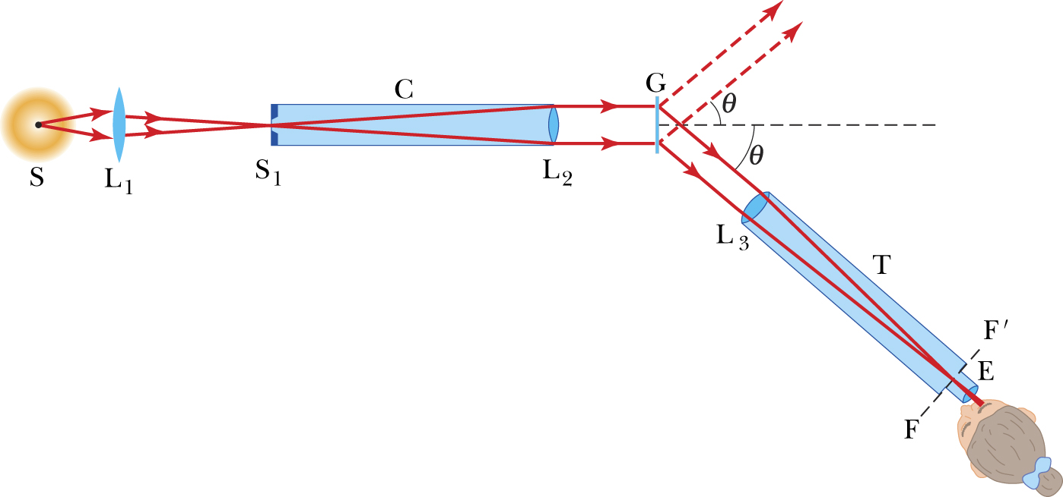
A spectroscope
There is an adjustable narrow slit, S₁, at the front of the collimator, C. The collimator is set up to shine parallel rays of light onto the diffraction grating or prism. (For the remainder of this investigation, we will assume that a diffraction grating is being used. We will assume that the information about the number of lines per metre is provided. It is possible to calibrate a grating, and a procedure to do this is included at the end of the investigation.)
The light that passes through the diffraction grating deviates through an angle that depends on the wavelength of the light and the number of lines per metre ruled on the diffraction grating.
The telescope, T, is rotated around the table, and the image of the narrow slit is observed at different angles for the different wavelengths of light. These angles can be measured, usually with the help of a vernier scale fixed to the telescope.
Setting up the spectroscope involves two parts: adjusting the telescope for parallel light rays, and adjusting the collimator to produce parallel light rays.
There should be fine cross-wires visible in the eyepiece of the telescope. These cross-wires should be in sharp focus, and an adjustment of the eyepiece in its holder may have to be made if they are not sharply focused.
The telescope should be pointed at a distant object and the focus adjusted using the objective lens of the telescope, lens L₃ in the figure above, until the image of the distant object is sharply focused. (In fact, any object outside should be far enough away.)
The telescope is then aligned with the collimator and the lens on the collimator, lens L₂ in the figure above, adjusted until the slit is seen sharply focused.
A light source, possibly a brighter spectral tube than the hydrogen tube, can now be set up in front of the slit and the slit width adjusted until narrow spectral lines can be viewed when the telescope is rotated to the appropriate position.
By clamping the telescope and then using the fine adjustment, it should be possible to align the cross-wires visible in the eyepiece with the spectral line. A measurement can then be made.
Reading a vernier scale
A vernier scale has ten lines on the moveable scale in the space of nine lines on the fixed scale. This enables an extra decimal place to be determined. This extra digit corresponds to the position of the line on the vernier (moveable) scale that aligns with any one of the lines on the fixed scale.
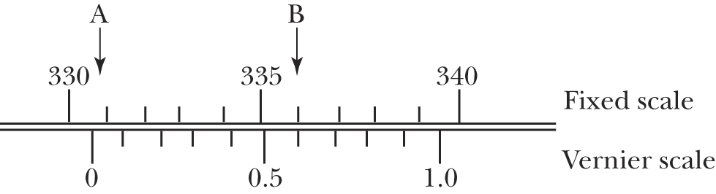

Reading a vernier scale. The position of the zero mark on the vernier scale, indicated by arrow A, is just less than 331. The line on the vernier scale that matches a line on the fixed scale is 0.7, as indicated by arrow B. The reading is therefore 330.7°.
Measuring the wavelengths of the spectral lines of hydrogen
The lines will probably be quite faint, and it will probably be necessary to have the apparatus in a darkened room to observe the lines clearly. The most difficult part is aligning the spectral lines with the cross-wires. If the room is completely dark, it will be impossible to see the cross-wires. A small amount of field illumination is necessary to be able to see the cross-wires.
There should be no problem with making the measurement for the straight through position. There should be sufficient light coming directly through the slit to make locating the image of the slit on the cross-wires quite easy.
Record this value, then record the reading of as many of the spectral lines as possible. (If it is possible to measure any of the spectral lines of the second order spectrum, it is worth doing so.) Record your results in table 22.1 below and calculate the wavelengths of the spectral lines.
The number of lines per centimetre or perhaps even the number of lines per inch is probably supplied with the diffraction grating. It will be necessary to convert this to lines per metre; d is the inverse of this value.
Record the reading of the straight through position θ₀.
Table 21.1A
Spectral line colour | Position θ | Angle θ – θ_{o} | Order of spectra (n) | Wavelength, $λ=\frac{d\text{sin}θ}{n}$
Faint violet |  |  | 1
Violet |  |  | 1
Blue-green |  |  | 1
Red |  |  | 1
 |  |  | 2
 |  |  | 2
 |  |  | 2
 |  |  | 2

Analysing the results
The energy of the ground state of hydrogen is E₁ = –13.6 eV.
The energies of the other states are given by $E_{n}=\frac{E_{1}}{n^{2}}$.
Determine the energy (in electron volts) of the energy states n = 2, 3, 4, 5, and 6. Draw an energy level diagram and calculate the energies (in electron volts) of photons emitted when an electron jumps to the n = 2 state from each of the four higher energy states. Convert these values from electron volts to joules and calculate the wavelengths of these photons.
(1 electron volt = 1.6 × 10^{–19} J, h = 6.602 × 10^{–34} J s)
$$\begin{aligned}E=hf \\ =\frac{\text{hc}}{λ} \\ λ=\frac{\text{hc}}{E}\end{aligned}$$
Compare the values of the wavelengths calculated above with the values determined from the measurements of the angles.
Questions
- How accurate do you consider your determination of the wavelengths of the spectral lines? Aside from any difficulty with aligning the spectral lines with the cross-wires, you are restricted to measuring the angle to the nearest 0.1°. Consider how a change in angle of 0.1° will alter your calculations.
- Taking into account the expected accuracy of your observations, do you consider that your results are in agreement with the theoretical values of the wavelengths of these four spectral lines of hydrogen?
Calibration of diffraction grating
If necessary, the diffraction grating could be calibrated using a sodium vapour spectral tube. Set up this tube and observe the angle to the very bright orange line in the first order spectrum of sodium (n = 1). This line is really a double line, the wavelengths of the lines being 589.0 nm and 589.6 nm.
You can use the information in the equation $λ=\frac{d\text{sin}q}{n}$ to calculate d.
Notes:

